Chaitanya Durgesh Nynavarapu  
A20561894

**ASSIGNMENT - 3**

**7. What is the earliest finish date for this project if it is scheduled to start on 10/14/24?**

* **5/13/25**

**8. Can this project be completed 2 months after it starts? Explain why yes or no.**

* No, it is not possible to complete the project in 2 months. Since the pool project is the one we have chosen to prioritize in the resource pool, resources will be assigned to it according to availability.
* **Project 1** 
  + Start date: 9/16/24
  + Finish Date: 11/25/24
* **Project 2**
* Start date: 9/23/24
* Finish Date: 6/2/25
* **Project 3** 
  + Start date: 10/14/24
  + Finish Date: 5/13/25

**10. Submit your Comments regarding the start and completion dates and resources assignments for the three projects in a PDF document called Analysis.pdf.**

**1. Document and comment on the WBS**

**Work Breakdown Structure (WBS)**

* **Project 1:**

1.1- Project plan

1.2 - Risk Mitigation and Contingency Plan

1.3 - Requirements1.4- Analysis

1.5 - Design

1.6 - Coding and unit test

1.7 - Testing

1.8 - Documentation

* **Project 2:**

1.1- Project plan

1.2 - Requirements

1.3 - Lab and Environment Setup

1.4 - Analysis/Design Document

1.5 - Data Model

1.6 - Coding and unit test

1.7 - Testing

1.8 - Documentation

1.9 - Training

* **Project 3:**

1.1 - Project plan

1.2 - Documented Software Development Process Updates

1.3 - Requirement

1.4 - Build the development and testing lab environment

1.5 - Analysis

1.6 - Design

1.7 - Coding

1.8 - Testing

1.9 – Documentation

**2. Document and comment on the Network Diagram**

* **Network Diagram**

The network diagram, which shows the path with the longest duration, aids in our ability to identify the crucial path. It offers a clearer understanding of the workflow.

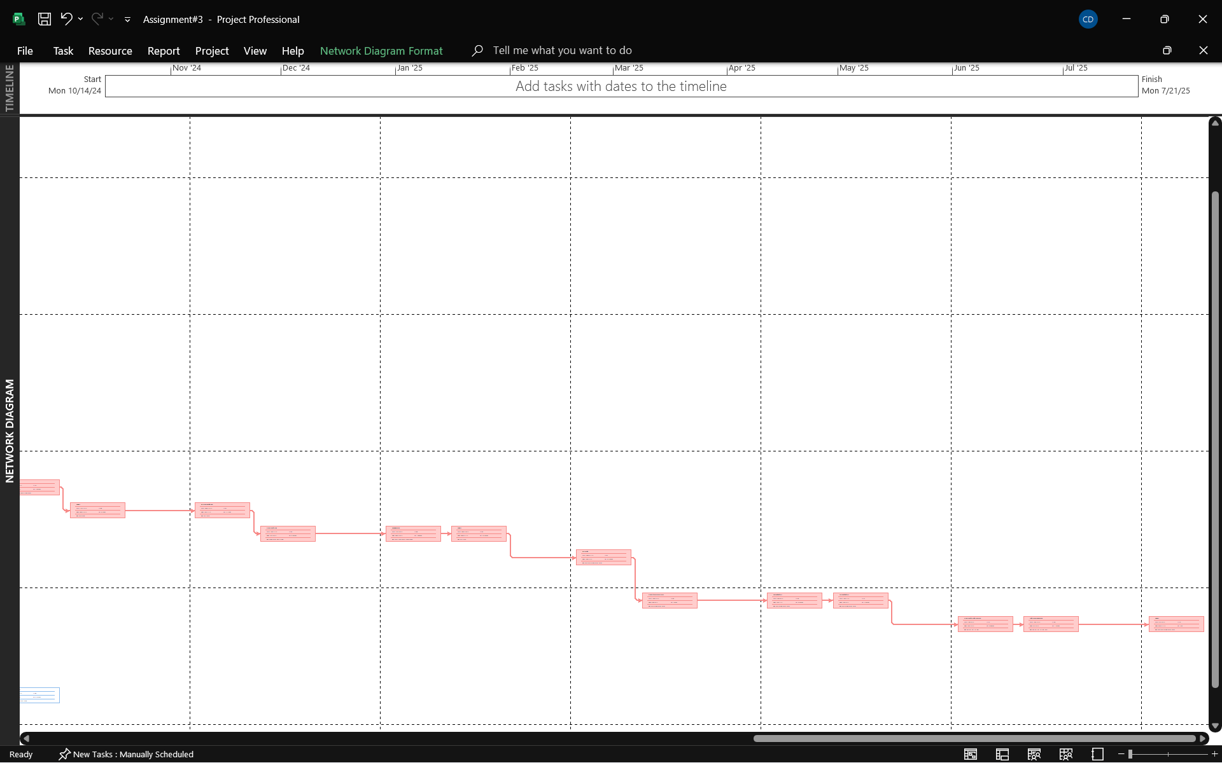

**3. Document and comment on the resource pool utilization**

* **Resource pool utilization**

The same pool of resources is used by all three programmers. Assignments 1 and 2 now include the resources for assignment 3. Through three distinct initiatives, we are sharing the resource pool in the assignment. We avoid overallocation by using resources according to their availability.

**4. Document the Baseline Estimation Calculations**